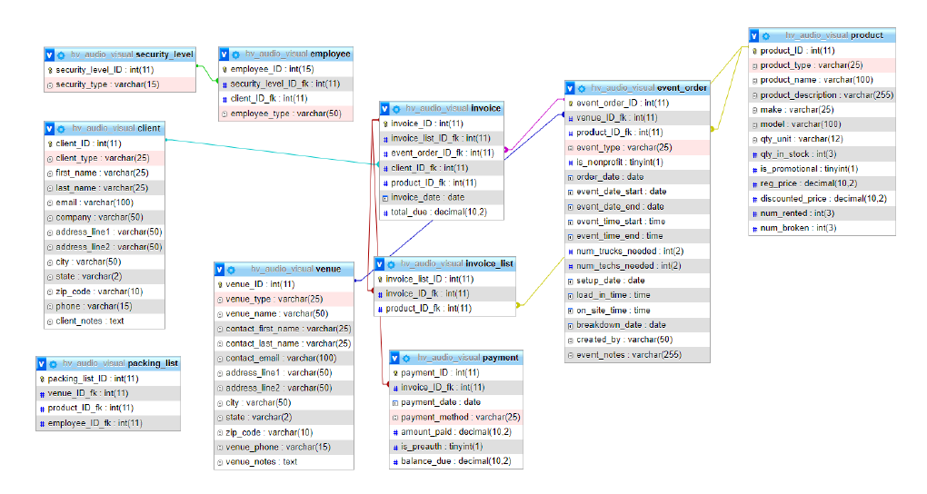

Jennie Q. Colabella

Hudson Valley Audio Visual Rental System

Group 1

database_designer_v2

2/16/22